LAB EXPERIMENTS
CYCLE 2
EXP 8:
Aim:
To implement DES encryption and decryption for secure data transmission.
Algorithm:
- Read plaintext and key.
- Perform encryption using the key.
- Generate ciphertext.
- Decrypt the ciphertext using the same key.
- Display the original plaintext
PROGRAM:
#include <stdio.h>

int main() {
char text[100], key;
int i;

printf("Enter Plain Text: ");
scanf("%s", text);

printf("Enter Key: ");
scanf(" %c", &key);

for(i=0;text[i]!='\0';i++)
text[i] ^= key;

printf("Encrypted Text: %s\n", text);

for(i=0;text[i]!='\0';i++)
text[i] ^= key;

printf("Decrypted Text: %s\n", text);

return 0;
}
OUTPUT:
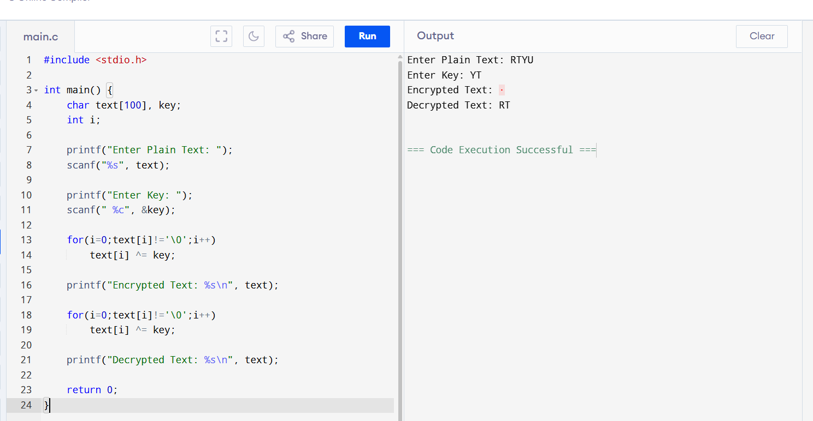
EXP 9:
Aim:
To implement Double DES encryption using two keys.
Algorithm:
- Read plaintext.
- Read Key1 and Key2.
- Encrypt plaintext using Key1.
- Encrypt the result using Key2.
- Decrypt using Key2 and then Key1.
- Display decrypted text.
PROGRAM:
#include <stdio.h>

int main() {
char text[100], k1, k2;
int i;

printf("Enter Text: ");
scanf("%s", text);

printf("Enter Key1: ");
scanf(" %c", &k1);

printf("Enter Key2: ");
scanf(" %c", &k2);

for(i=0;text[i]!='\0';i++) {
text[i] ^= k1;
text[i] ^= k2;
}

printf("Encrypted: %s\n", text);

for(i=0;text[i]!='\0';i++) {
text[i] ^= k2;
text[i] ^= k1;
}

printf("Decrypted: %s\n", text);

return 0;
}
OUTPUT:
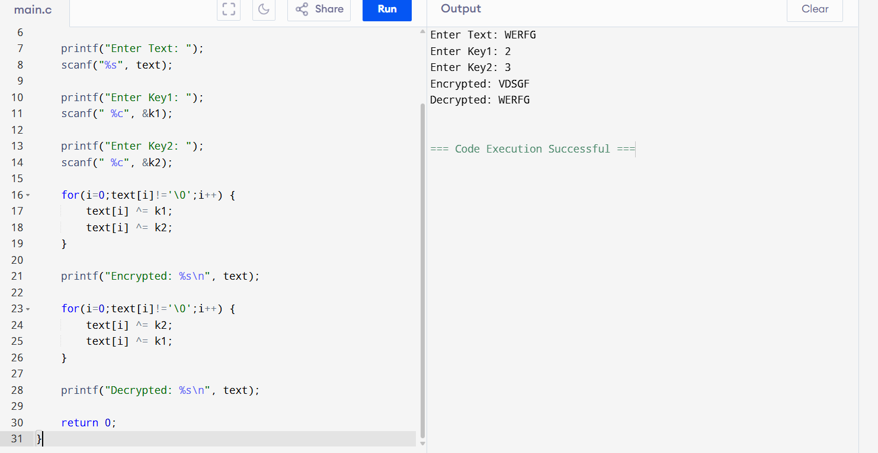

EXP 10:
Aim:
To implement Triple DES encryption using three keys.
Algorithm:
- Read plaintext.
- Read three keys.
- Encrypt with Key1.
- Encrypt with Key2.
- Encrypt with Key3.
- Decrypt in reverse order.
- Display results.
PROGRAM:
#include <stdio.h>

int main() {
char text[100], k1, k2, k3;
int i;

printf("Enter Text: ");
scanf("%s", text);

printf("Enter Key1: ");
scanf(" %c",&k1);

printf("Enter Key2: ");
scanf(" %c",&k2);

printf("Enter Key3: ");
scanf(" %c",&k3);

for(i=0;text[i]!='\0';i++) {
text[i]^=k1;
text[i]^=k2;
text[i]^=k3;
}

printf("Encrypted: %s\n", text);

for(i=0;text[i]!='\0';i++) {
text[i]^=k3;
text[i]^=k2;
text[i]^=k1;
}

printf("Decrypted: %s\n", text);

return 0;
}
OUTPUT:
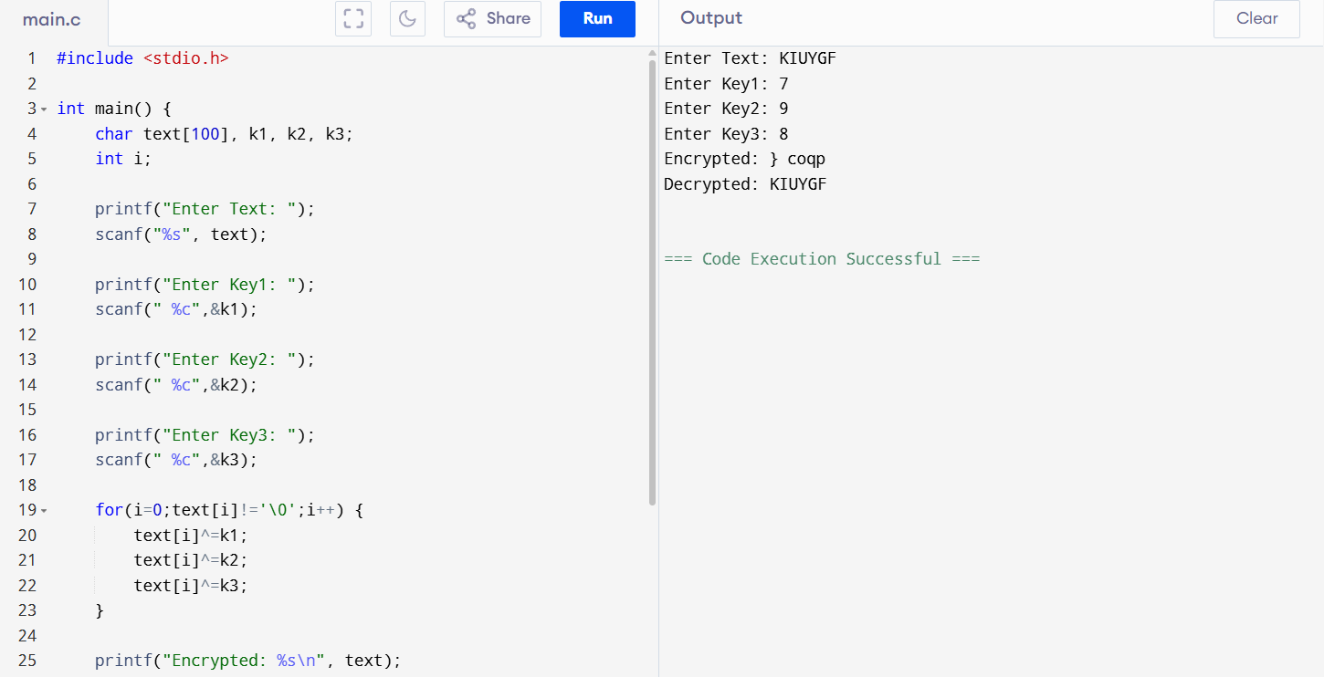
EXP 11:
Aim
To simulate different DES modes of operation.
Algorithm
- Read plaintext, key, and IV.
- Select the mode.
- Apply corresponding encryption operation.
- Display ciphertext.
PROGRAM:
#include <stdio.h>

int main() {
int pt,key,iv,ch;

printf("Enter Plaintext: ");
scanf("%d",&pt);

printf("Enter Key: ");
scanf("%d",&key);

printf("Enter IV: ");
scanf("%d",&iv);

printf("1.ECB\n2.CBC\n3.CFB\n4.OFB\n5.CTR\n");
scanf("%d",&ch);

switch(ch) {
case 1:
printf("ECB = %d", pt^key);
break;

case 2:
printf("CBC = %d", (pt^iv)^key);
break;

case 3:
printf("CFB = %d", pt^(iv^key));
break;

case 4:
printf("OFB = %d", pt^(key^iv));
break;

case 5:
printf("CTR = %d", pt^(key+iv));
break;

default:
printf("Invalid Choice");
}
return 0;
}
OUTPUT:
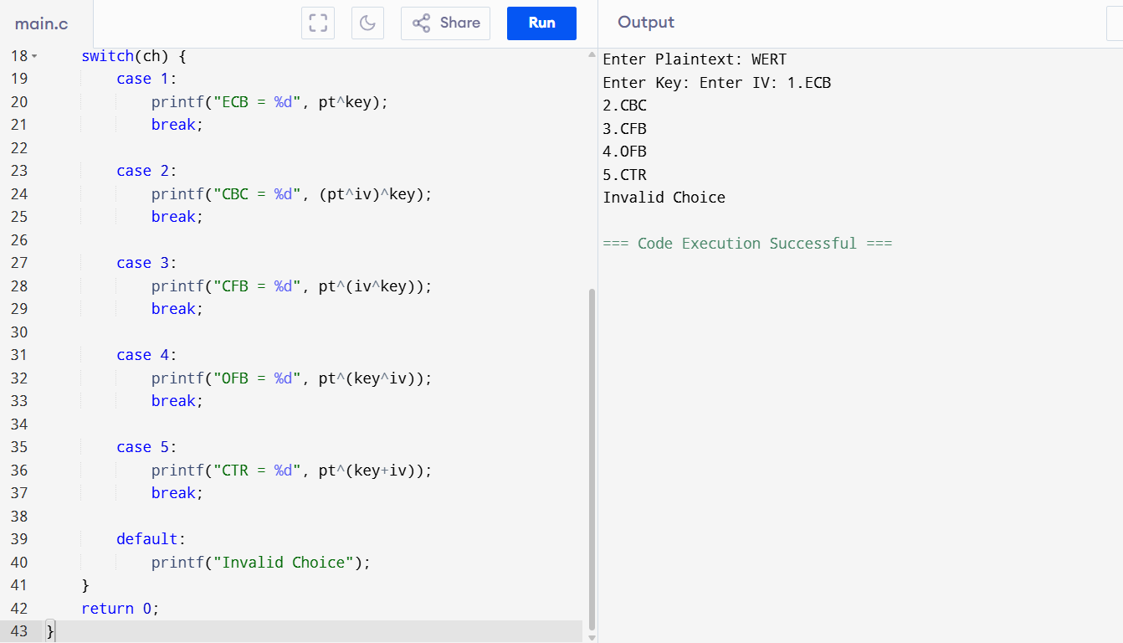
EXP 12:
Aim
To implement RSA public-key cryptography for encryption and decryption.
Algorithm
- Choose prime numbers p and q.
- Calculate n = p × q.
- Select public key e.
- Compute private key d.
- Encrypt message using e.
- Decrypt ciphertext using d.
PROGRAM:
#include <stdio.h>
#include <math.h>
int main() {
int p=3,q=11,n,e=7,d=3;
int m,c,dec;
printf("Enter Message (<33): ");
scanf("%d",&m);
n=p*q;
c=(int)pow(m,e)%n;
dec=(int)pow(c,d)%n;
printf("Encrypted = %d\n",c);
printf("Decrypted = %d\n",dec);
return 0;
}
OUTPUT:
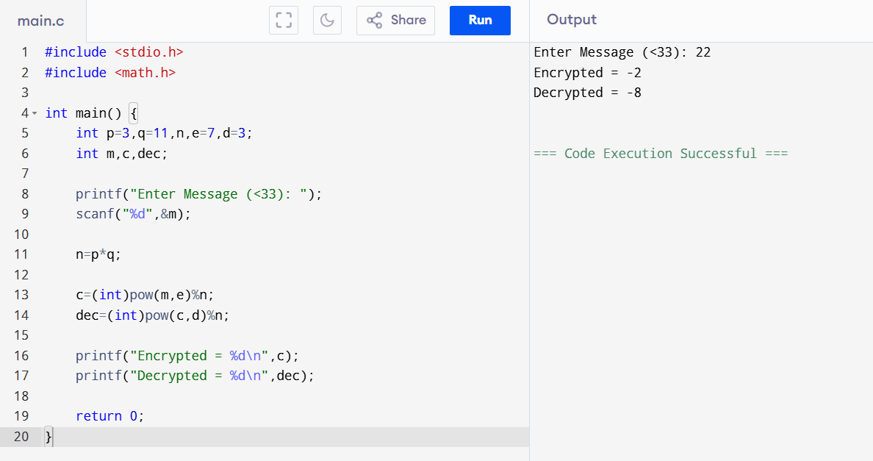

EXP 13:
Aim
To implement Diffie-Hellman key exchange to generate a shared secret key.
Algorithm
- Select prime number P and generator G.
- Choose private keys for users A and B.
- Generate public keys.
- Exchange public keys.
- Compute shared secret key.
- Verify both keys are equal.
PROGRAM:
#include <stdio.h>
#include <math.h>

int main() {
int P=23,G=9;
int a=4,b=3;
int x,y,ka,kb;

x=(int)pow(G,a)%P;
y=(int)pow(G,b)%P;

ka=(int)pow(y,a)%P;
kb=(int)pow(x,b)%P;

printf("Public Key A = %d\n",x);
printf("Public Key B = %d\n",y);

printf("Secret Key A = %d\n",ka);
printf("Secret Key B = %d\n",kb);

return 0;
}
OUTPUT:
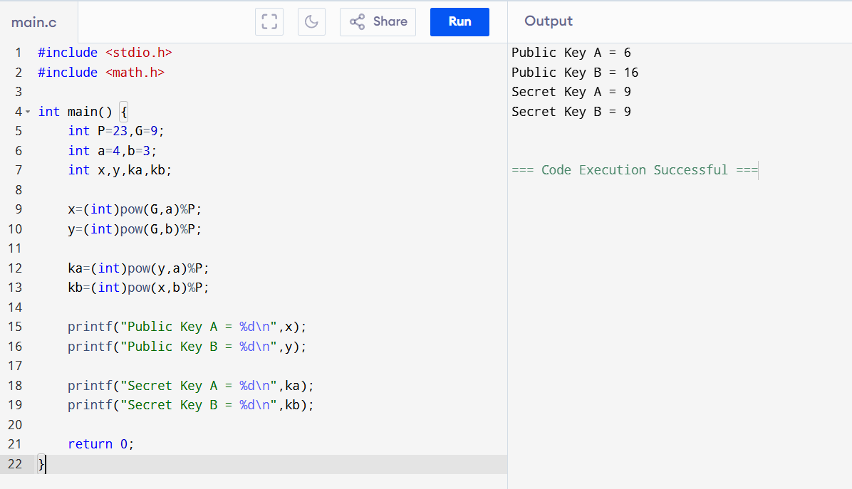
EXP 14:
Aim
To verify whether a point lies on a given elliptic curve.
Algorithm
- Read values of a and b.
- Read point (x,y).
- Compute y².
- Compute x³ + ax + b.
- Compare both values.
- Display the result.
PROGRAM:
#include <stdio.h>
int main() {
int a,b,x,y,lhs,rhs;
printf("Enter a: ");
scanf("%d",&a);
printf("Enter b: ");
scanf("%d",&b);
printf("Enter x: ");
scanf("%d",&x);
printf("Enter y: ");
scanf("%d",&y);
lhs = y*y;
rhs = x*x*x + a*x + b;
if(lhs == rhs)
printf("Point lies on the curve\n");
else
printf("Point does not lie on the curve\n");
return 0;
}
OUTPUT:
